SET 3
- Line Chart
Aim: To create a line chart to visualize the performance trend of employees based on their years of service.
Program
employee_id <- c(1, 2, 3, 4, 5)
department <- c("Sales", "HR", "Marketing", "Sales", "HR")
years <- c(5, 3, 7, 4, 2)
performance <- c(85, 92, 78, 90, 76)
plot(years, performance,
type = "o",
xlab = "Years of Service",
ylab = "Performance Score",
main = "Employee Performance Trend",
pch = 16)
legend("topright",
legend = "Performance Score",
lty = 1,
pch = 16)
Output:
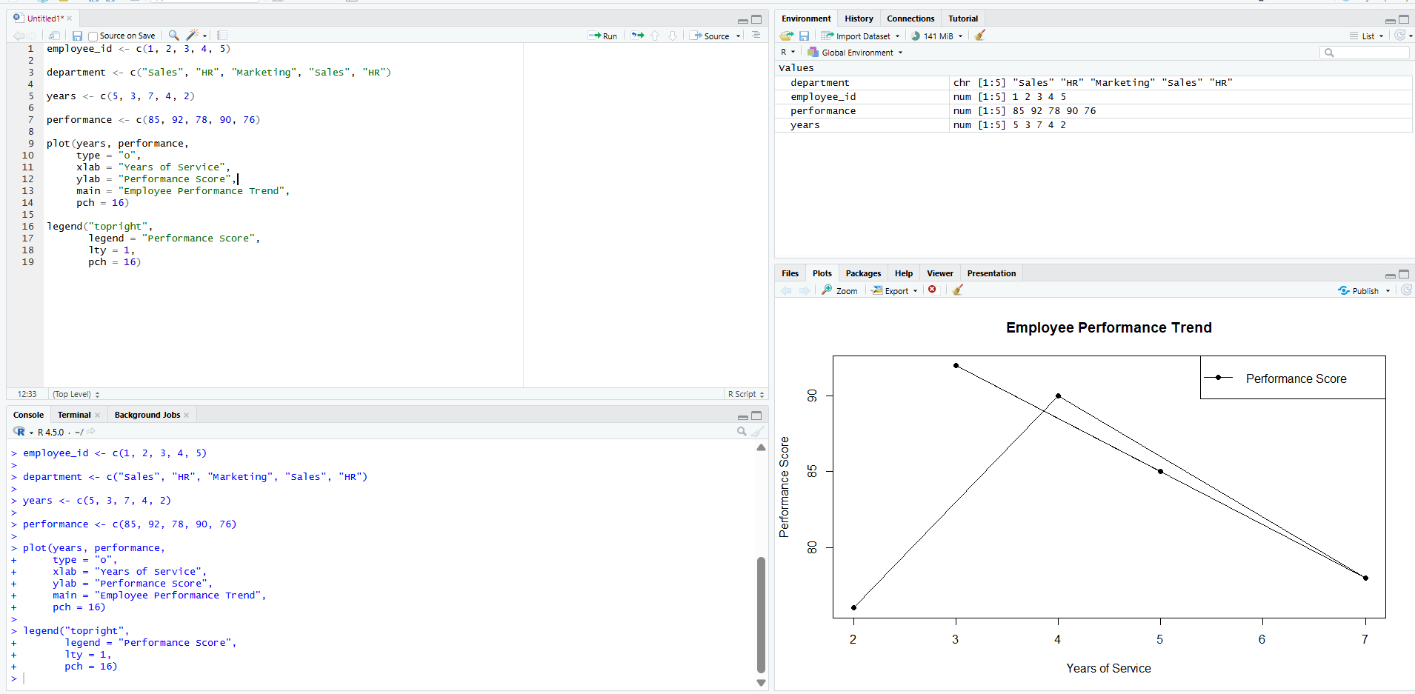
- Bar Chart
Aim: To create a bar chart to show the distribution of employees across different departments.
employee_id <- c(1, 2, 3, 4, 5)
department <- c("Sales", "HR", "Marketing", "Sales", "HR")
years <- c(5, 3, 7, 4, 2)
performance <- c(85, 92, 78, 90, 76)
department_count <- table(department)
barplot(department_count,
main = "Employees by Department",
xlab = "Department",
ylab = "Number of Employees",
col = "skyblue")
OUTPUT:
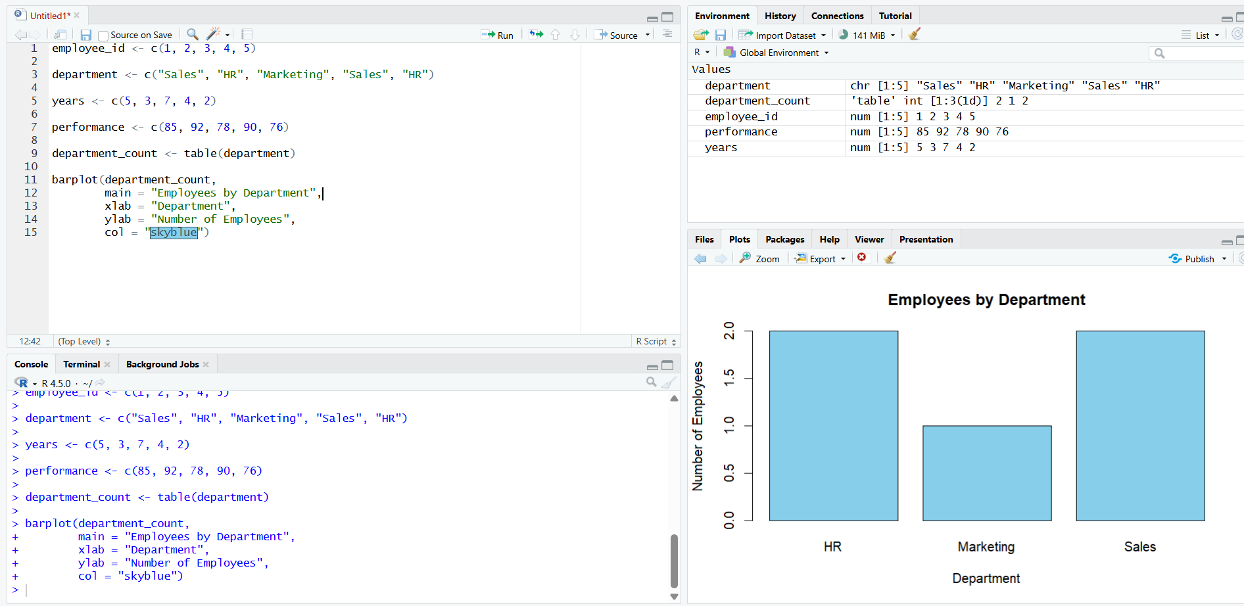
- Scatter Plot
Aim: To create a scatter plot to analyze the relationship between years of service and employee performance scores.

Program:
employee_id <- c(1, 2, 3, 4, 5)
department <- c("Sales", "HR", "Marketing", "Sales", "HR")
years <- c(5, 3, 7, 4, 2)
performance <- c(85, 92, 78, 90, 76)
plot(years, performance,
xlab = "Years of Service",
ylab = "Performance Score",
main = "Years of Service vs Performance",
pch = 19)
Output:
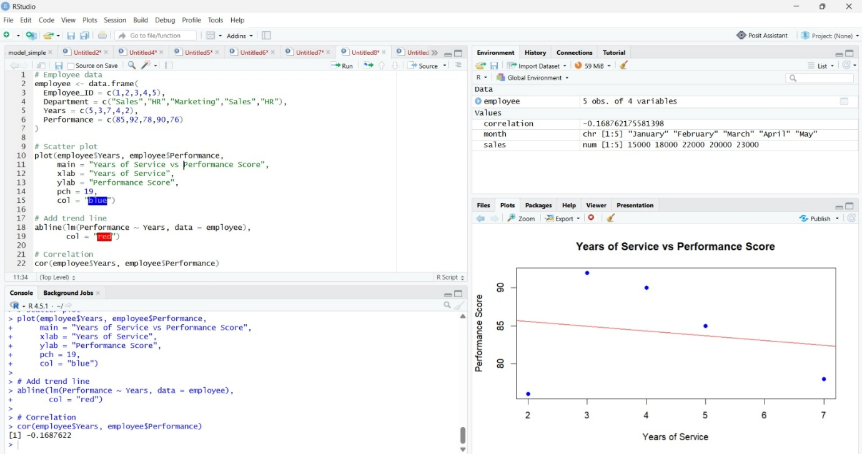

- Tableau Dashboard
Aim: To develop an interactive Tableau dashboard combining the line chart and bar chart for exploring employee performance data.
PROGRAM:
# Employee data
employee <- data.frame(
Employee_ID = c(1,2,3,4,5),
Department = c("Sales","HR","Marketing","Sales","HR"),
Years_of_Service = c(5,3,7,4,2),
Performance_Score = c(85,92,78,90,76)
)

# Save data as CSV
write.csv(employee,
"employee_performance.csv",
row.names = FALSE)
# Display data
print(employee)
Output:

